Name Quang Huynh

**Inquiry Lab Form**

*Question: Does the amount of a material affect its density? (What will happen if I measure the density of different masses and volumes of wood blocks?*

*Independent Variable: Size of blocks*

*Dependent Variable: Density*

*Constants: Type of wood*

Hypothesis / Model / Drawing

If the size of the wood changes,

then the density will still stay the same



**Data Tables:**

|  |  |  |  |
| --- | --- | --- | --- |
| Object | Mass | Volume | Density |
| Wood; C3 | 32.5 g | 55.9 cm3 | 0.6g/cm3 |
| Wood; B | 18.2 g | 28.4 cm3 | 0.6g/cm3 |
| Wood; C1 | 23.5 g | 36.7 cm3 | 0.6g/cm3 |
| Wood; K | 28 g | 45 cm3 | 0.6g/cm3 |
| Wood; P | 10.2 g | 22.3 cm3 | 0.5g/cm3 |

**Graph:**

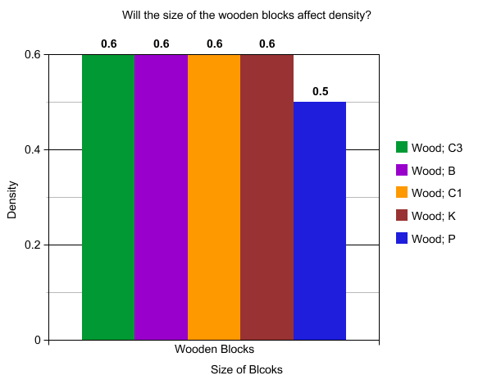

**Conclusion:**

Claim:

My claim is, the size of the wooden blocks will not change the density of the blocks, but if the density does change in some occasions, then the block would still float in the water due to the density under 1g/cm3 (water density)

Evidence:

My evidence for this is the lab that we just did, where we had to find the mass of 5 blocks which all had different results, and then we had to find the volume of each block, which was also all different.

Then, we used the density formula, D= mass/volume to figure out the density of all the blocks, and then when we rounded the density to a tenth, it was 0.6 or 0.5 g/cm3

Reasoning:

The reason to why the blocks were the same density was that because the blocks were all made from the same material, wood. Which has a density of 0.6g/cm3. Which means that it doesn’t matter about the size of the blocks, since the density would be always the same or close due to the block’s volume and mass contrasting to 0.6g/cm3.